David Olson, Sec 2

Whiteboard Experience for Project 5

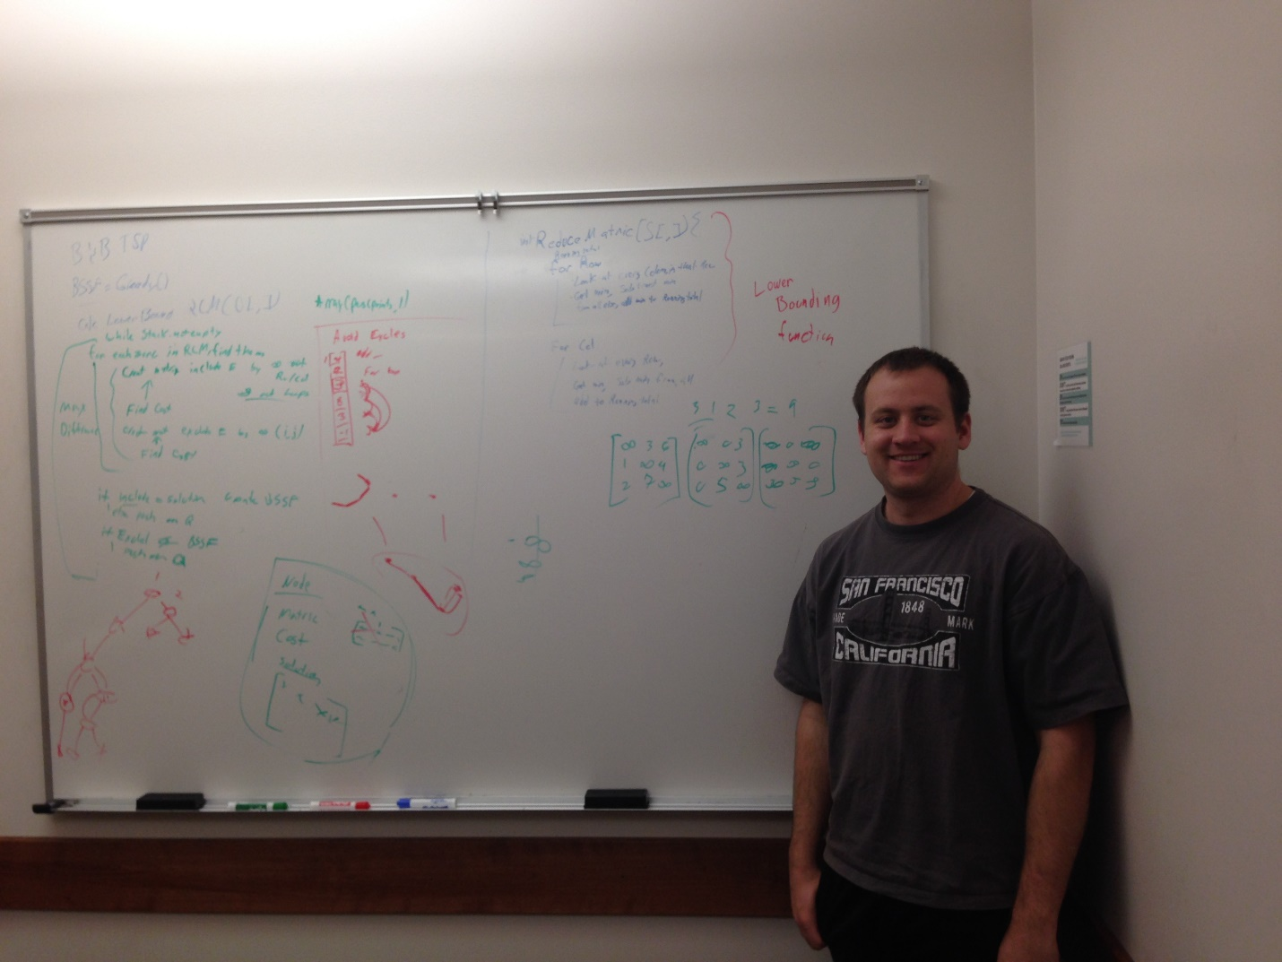

On the right of the board in blue is a reduce matrix function, which is called many times and returns the cost of reduction. On the right in green is an example of that function being called. On the left of the board in green we have the main algorithm, and also the shell of a node class. In red on the left there is a small example, and a little demonstration of how the path array and partial loop protection might work. I’m there in the picture too, amazed that this is my last whiteboard experience of my life, yet only my 5th. Life sure does have a way of being surreal.